Sesion 4.5

Juan José Merino Zarco

30/6/2021

# Graficos

pacman::p_load(ggplot2)

## Nueva base datos, mtcars

mtcars

## mpg cyl disp hp drat wt qsec vs am gear carb  
## Mazda RX4 21.0 6 160.0 110 3.90 2.620 16.46 0 1 4 4  
## Mazda RX4 Wag 21.0 6 160.0 110 3.90 2.875 17.02 0 1 4 4  
## Datsun 710 22.8 4 108.0 93 3.85 2.320 18.61 1 1 4 1  
## Hornet 4 Drive 21.4 6 258.0 110 3.08 3.215 19.44 1 0 3 1  
## Hornet Sportabout 18.7 8 360.0 175 3.15 3.440 17.02 0 0 3 2  
## Valiant 18.1 6 225.0 105 2.76 3.460 20.22 1 0 3 1  
## Duster 360 14.3 8 360.0 245 3.21 3.570 15.84 0 0 3 4  
## Merc 240D 24.4 4 146.7 62 3.69 3.190 20.00 1 0 4 2  
## Merc 230 22.8 4 140.8 95 3.92 3.150 22.90 1 0 4 2  
## Merc 280 19.2 6 167.6 123 3.92 3.440 18.30 1 0 4 4  
## Merc 280C 17.8 6 167.6 123 3.92 3.440 18.90 1 0 4 4  
## Merc 450SE 16.4 8 275.8 180 3.07 4.070 17.40 0 0 3 3  
## Merc 450SL 17.3 8 275.8 180 3.07 3.730 17.60 0 0 3 3  
## Merc 450SLC 15.2 8 275.8 180 3.07 3.780 18.00 0 0 3 3  
## Cadillac Fleetwood 10.4 8 472.0 205 2.93 5.250 17.98 0 0 3 4  
## Lincoln Continental 10.4 8 460.0 215 3.00 5.424 17.82 0 0 3 4  
## Chrysler Imperial 14.7 8 440.0 230 3.23 5.345 17.42 0 0 3 4  
## Fiat 128 32.4 4 78.7 66 4.08 2.200 19.47 1 1 4 1  
## Honda Civic 30.4 4 75.7 52 4.93 1.615 18.52 1 1 4 2  
## Toyota Corolla 33.9 4 71.1 65 4.22 1.835 19.90 1 1 4 1  
## Toyota Corona 21.5 4 120.1 97 3.70 2.465 20.01 1 0 3 1  
## Dodge Challenger 15.5 8 318.0 150 2.76 3.520 16.87 0 0 3 2  
## AMC Javelin 15.2 8 304.0 150 3.15 3.435 17.30 0 0 3 2  
## Camaro Z28 13.3 8 350.0 245 3.73 3.840 15.41 0 0 3 4  
## Pontiac Firebird 19.2 8 400.0 175 3.08 3.845 17.05 0 0 3 2  
## Fiat X1-9 27.3 4 79.0 66 4.08 1.935 18.90 1 1 4 1  
## Porsche 914-2 26.0 4 120.3 91 4.43 2.140 16.70 0 1 5 2  
## Lotus Europa 30.4 4 95.1 113 3.77 1.513 16.90 1 1 5 2  
## Ford Pantera L 15.8 8 351.0 264 4.22 3.170 14.50 0 1 5 4  
## Ferrari Dino 19.7 6 145.0 175 3.62 2.770 15.50 0 1 5 6  
## Maserati Bora 15.0 8 301.0 335 3.54 3.570 14.60 0 1 5 8  
## Volvo 142E 21.4 4 121.0 109 4.11 2.780 18.60 1 1 4 2

?mtcars

## starting httpd help server ... done

## Graficas por defecto de R

barplot()

cylfactor <- table(mtcars$cyl)  
  
barplot(cylfactor,  
 main = "Grafico de barras",  
 xlab = "Num. de Cilindros",  
 ylab = "Num. de vehiculos")

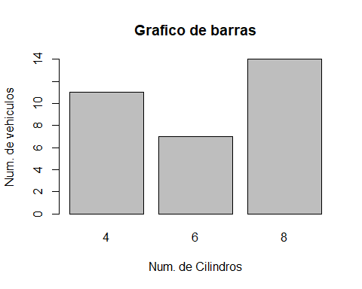

## Graficos con ggplot

qplot()

qplot(mtcars$cyl,  
 main = "Grafico de barras",  
 xlab = "Num. de Cilindros",  
 ylab = "Num. de vehiculos",  
 geom = "bar",  
 color = I("black"),  
 fill = I("Red"))

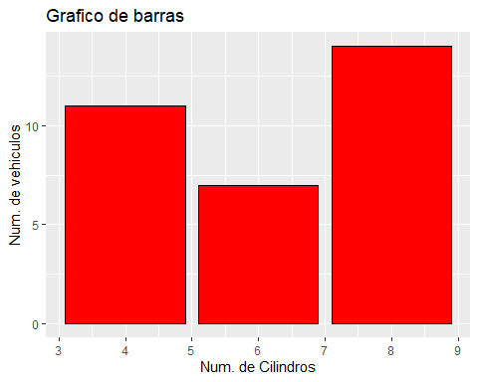

## Graficas con ggplot()

ggplot(mtcars, aes(cyl)) + geom_bar()

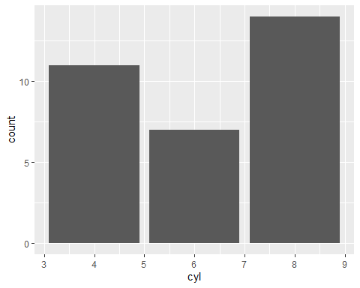

ggplot(mtcars, aes(x=as.factor(cyl))) + geom_bar(aes(fill=as.factor(cyl))) + scale_fill_brewer(name = "Cilindros", palette = "Blues") + labs(x = "Numero de cilindros",y= "Numero de vehiculos", title = "Grafica de barras")

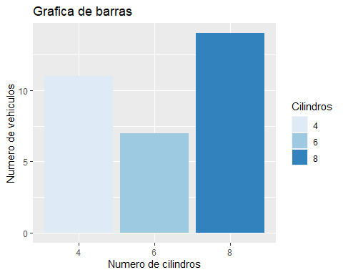

# Recursos adicionales

**Cheat Sheet de ggplot2**

<https://github.com/rstudio/cheatsheets/blob/master/data-visualization-2.1.pdf>

**Modificar etiquetas de las graficas**

<https://www.datanovia.com/en/blog/ggplot-legend-title-position-and-labels/>

**R for Data Science (GGplot2)**

<https://rstudio-pubs-static.s3.amazonaws.com/318832_e8443ac15f704debacd04107ae000e17.html#barplot>

**ggplot2 Quick Reference: colour (and fill)**

<http://sape.inf.usi.ch/quick-reference/ggplot2/colour>

**R Graphics Essentials for Great Data Visualization: +200 Practical**

<https://www.amazon.com.mx/Graphics-Essentials-Great-Data-Visualization-ebook/dp/B077H23KVK>